Design Of Planar Monople Antenna For Wireless and Energy Harvesting Applications
Amit Kumar Varshney, Chemirthipalli Girish Duggineni BhanuPrakash
Assistant Professor, Department of ECE, UG Student, Department of ECE, UG Student, Department of ECE,
Saveetha Engineering College, Saveetha Engineering College, Saveetha Engineering College,
Chennai, Tamil Nadu, India Chennai, Tamil Nadu, India Chennai, Tamil Nadu, India
amitkumar@saveetha.ac.in girish02526@gmail.com bhanuchowdaryduggineni@gmail.com

Abstract— A planar circular monopole antenna with slots/slits in the patch and ground plane is presented. With reduced resonant frequency and enhanced bandwidth is presented. Slots/slits in patch and ground plane give rise to band rejection in some frequency range. The antenna operates over a wide frequency range, covering some of wireless standards/protocols at the same time, such as Wi-Fi, WiMAX, Bluetooth, RFID and GPS (L1). The antenna is simulated in HFSS and measured using pocket VNA. The simulated result shows S11 parameter less than -10dB from 0.72GHz to 1.24GHz and again from 1.52GHz to 2.65GHz. The measured result shows S11 parameter of around -10dB and less from 0.628GHz to 1.28GHz and again from 1.466GHz to 2.72GHz. Without using any slot in the ground plane and patch, the simulated result shows S₁₁ parameter less than -10dB from 0.85GHz to 2.18GHz. The simulated gain obtained is around 4dBi at almost all the frequencies. Thus simulated results closely match with the measured results. Without using slots/slits, the simulated S-parameter shows S11 less than -10dB from 0.84GHz to 2.25GHz. The fabricated antenna occupies the dimension of 160mm76mm. The substrate used in the antenna is FR4 epoxy having relative permittivity 4.4 and thickness 1.6mm. The designed antenna, besides its use in wireless communication, finds application in energy harvesting where low frequencies are abundantly present in the environment.
Keywords—circular monopole, energy harvesting, slots.

I. Introduction

Owing to the emergence of several wireless standards and protocols it has become necessary to design an antenna that can operate in multiple frequencies. This calls for broad banding an antenna. A planar monopole antenna is inherently broadband because it is evolved from microstrip patch antenna by increasing the substrate height and decreasing the permittivity of substrate since both height and permittivity of the substrate have direct affect on the bandwidth [1, 2]. For planar monopole antenna ground plane can be thought to be at infinity and permittivity close to 1 (air substrate) [3]. Increasing the thickness of the monopole further increases the bandwidth [3]. At the design frequency, the monopole antennas should be a quarter of a wavelength long. If the radius of the cylinder is made thicker, the bandwidth of the antennas can be increased. The same approach applies to planar monopole antennas: instead of utilizing a 50 ohm metal strip for the monopole, a wider strip (rectangular shape) or any other shape (triangular, circular, ellipse, etc.) can be used to achieve broadband characteristics. Further optimization of the broadband characteristics can be performed by introducing defects in the ground plane (by etching slots or slits) and/or etching slots/slits in the monopole. This is the guiding premise for this type of research. Different authors in the past have reported modification in the basic structure of planar microstrip and monopole antennas for bandwidth enhancement and miniaturization. In one such paper [4], the author has reported an array of two U shaped planar monopole antennas and a slit in the ground plane to achieve 80% fractional bandwidth. Authors in [5] have designed annular ring shaped microstrip patch antenna with ground plane of hexagonal shaped to achieve 151% of fractional bandwidth due to the excitation of closely spaced multimode [5]. The multimode may be from same antenna or from two closely spaced antennas [6-7]. In [8], authors have reported that cutting U shaped slot in the microstrip patch/ground plane enhances bandwidth due to alteration of current path [8]. In [9] authors have reported tapered feed for MIMO antenna resulting in huge bandwidth. In this work, the two antennas are orthogonally fed which resulted in good isolation between antennas. In [10], the authors have reported three radiating strips and a special technique is used to improve bandwidth and impedance matching by applying back coupling pad, resulting in huge bandwidth from 2.315GHz to 5.285GHz (a total of 2.972GHz). In [11], the authors have reported U shaped microstrip patch with circular slots in the ground plane achieving 81% fractional bandwidth. In [12], the authors have reported an eye shaped slot in dipole antenna resulting in the improvement of impedance bandwidth (from 3.1 to 12 GHz) and gain bandwidth. The authors in [13] have reported the use of metamaterial structures using complementary split ring resonators on the patch resulting in fractional bandwidth of 76%.

Antennas also find applications in harnessing RF energy from environment. For better harnessing the RF energy from ambient environment, it is desired to have omnidirectional radiation pattern of the antenna. Monopole antennas are a very good choice for such applications. Antennas for energy harvesting applications do not require to be compact. However planar antennas are preferred as these can be integrated with microwave circuitry required with antenna for RF energy harvesting like rectifiers etc. [14] Authors in [14] have designed and optimized a rectifier combined with a broadband planar monopole antenna (called rectina) which can be used for RF energy harvesting.

The advancement of current world technology, as well as customer demand for multiple services offered by a single wireless device, has influenced the need for an antenna capable of transmitting and receiving electromagnetic waves across multiple frequency bands. A distinct frequency band is associated with each wireless service. The most prevalent wireless services are listed, along with their respective frequency ranges.

Frequency ranges wireless service

860-960MHz RFID
2.51-2.55GHz WiMAX band
2100MHz UMTS(3G of GSM)
824-890MHz CDMA
1575+-10MHz GPS
890-915MHz and 935-960MHz GSM(900)
1710-1780MHz and 1810-1880MHz GSM(1800)
1920-1980MHz and 2110-2170MHz 3G
2300-2400MHz 4G
2400-2483MHz Wi-Fi

Here the authors have reported a novel broadband planar monopole antenna that will cover simultaneously a number wireless standards and protocols (especially the standards at low frequencies) so that the designed antenna finds application in wireless and as an energy harvester.

II. Design of the proposed antenna
To start with, a planar circular monopole antenna without any slot/slit is designed and simulated in simulation software as shown in Fig. 1. One side of the substrate consists of circular monopole with microstrip line (top side) and the other side (bottom side) consists of only ground plane. The antenna is fabricated on FR4 epoxy substrate with relative permittivity 4.4 and is 1.6mm thick. The dimensions are optimized for better impedance matching. The initial length of monopole is obtained using the available analytical formulation available in literature [3]. The length of the wire monopole antenna is quarter-wave long at the design frequency with some correction factor. With increase in the thickness of the radius of the wire, the bandwidth increases. Since the frequency response is broadband, the antenna does not have a particular resonant frequency, the lower frequency for which S11=-10dB can be estimated by equating the area of the monopole with thin cylindrical monopole having same height. If the area of the circular monopole is 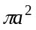, where ‘a’ is the radius of the circular disk, then the length of the thin cylindrical monopole should be L=2a. If the radius of this cylindrical monopole is r then its area is 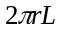. Equating the areas of circular monopole and cylindrical monopole, we obtain 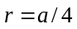.

For a cylindrical wire monopole antenna having length L and radius r, the following relation holds [3]
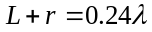 (1)
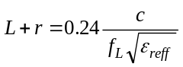 (2)
where 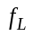is the lower cutoff frequency
Here 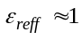(since we are considering air dielectric)
This simplifies to
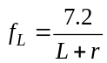GHz (3)
where L and r to be considered in cm.
In order to account for the gap ‘p’ (3) modifies to
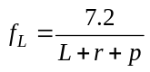GHz (4)
This is the basic design equation.
In the present optimized design, a=36mm. Hence r=9mm, L=72mm, p=5.3mm. Putting these values in (4) we obtain f_{L}=834.298MHz.

Fig.(a) Top side
epoxy

Fig.(b) Bottom side
After optimization of the basic circular monopole antenna, three slots in the patch are introduced, one U shaped and two rectangular shaped on either side of U shaped, and two slots in the ground plane, one slot of semicircular shape just below the transmission line and another rectangular slot at a distance away from the transmission line. The dimensions of the slots in the patch and in the ground plane are optimized in the simulation software for better impedance matching. The final optimized dimensions of the antenna with all the slots is shown in Fig. 2

Fig.(a) Top side

Fig. (b) bottom side

III. Results And Discussion
The simulated S₁₁ parameter (magnitude only) less than -10dB for the simple circular shaped monopole antenna is obtained from 0.85GHz to 2.18GHz as shown in Fig. 3. After cutting slots in the patch and ground plane, the S₁₁ parameter less than -10dB is obtained from 0.72GHz to 1.24GHz and again from 1.52GHz to 2.65GHz as shown in the same Fig. 3 We thus observe that after cutting slots, the lower cutoff frequency is reduced and the upper cutoff frequency is increased, S₁₁ parameter is slightly more than -10dB around 1.3GHz. The simulated 3D radiation pattern (plot of gain in dBi) of the slotted monopole antenna at 0.9GHz is shown in Fig.4. The radiation pattern of the fabricated antenna is shown in Fig. 5. The proposed antenna is then fabricated, as shown in Fig. 6, and its S-parameter measured using pocket VNA. Whose set up is shown in Fig. 7. The measured S-parameter shows S₁₁ less than -10dB from 0.628GHz to 1.28GHz and again from 1.466GHz to 2.72GHz. The measured and simulated S-parameter S₁₁ are compared in Fig. 8. Both measured and simulated results closely agree.
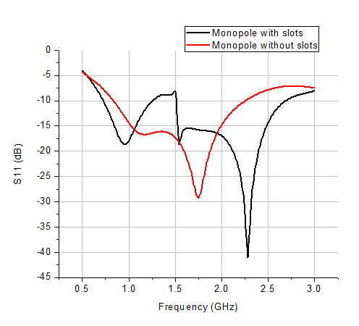
Fig. 3. Simulated S₁₁ parameter (magnitude only) of simple circular monopole antenna with and without slots.
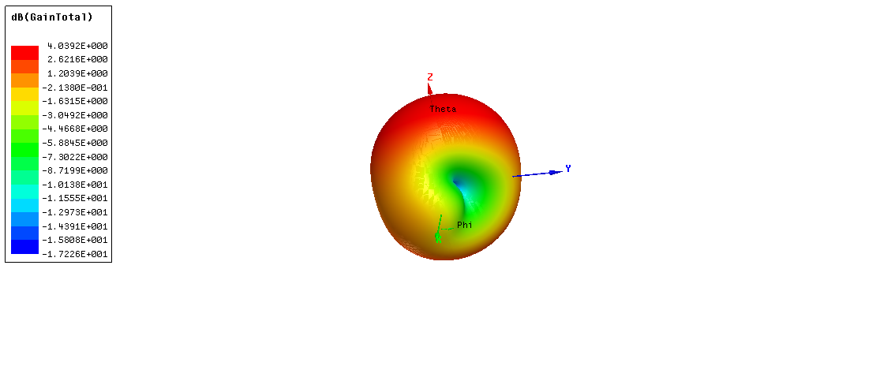
Fig. 4. Simulated radiation pattern of slotted monopole antenna at 0.9GHz
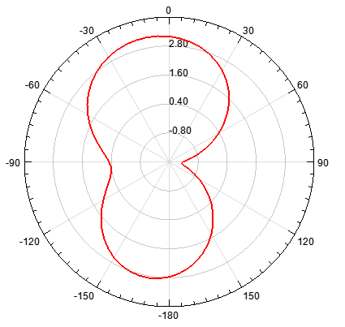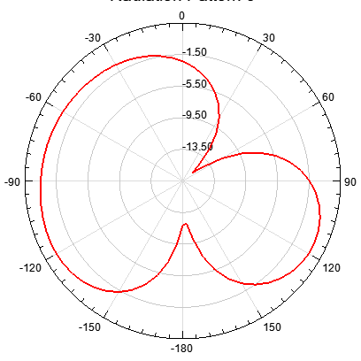
(a) (b) (b)
Fig. 5. Simulated 2D radiation pattern in y-z plane (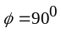) (H-plane) (a) and in x-y plane (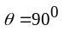) (b) at 0.9GHz (E-plane)
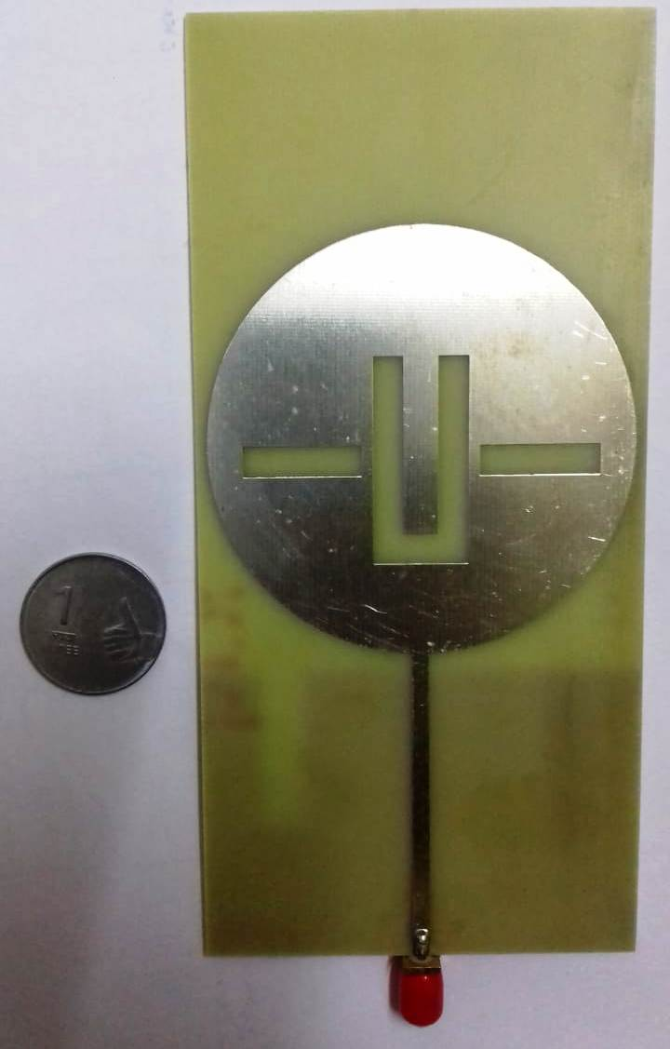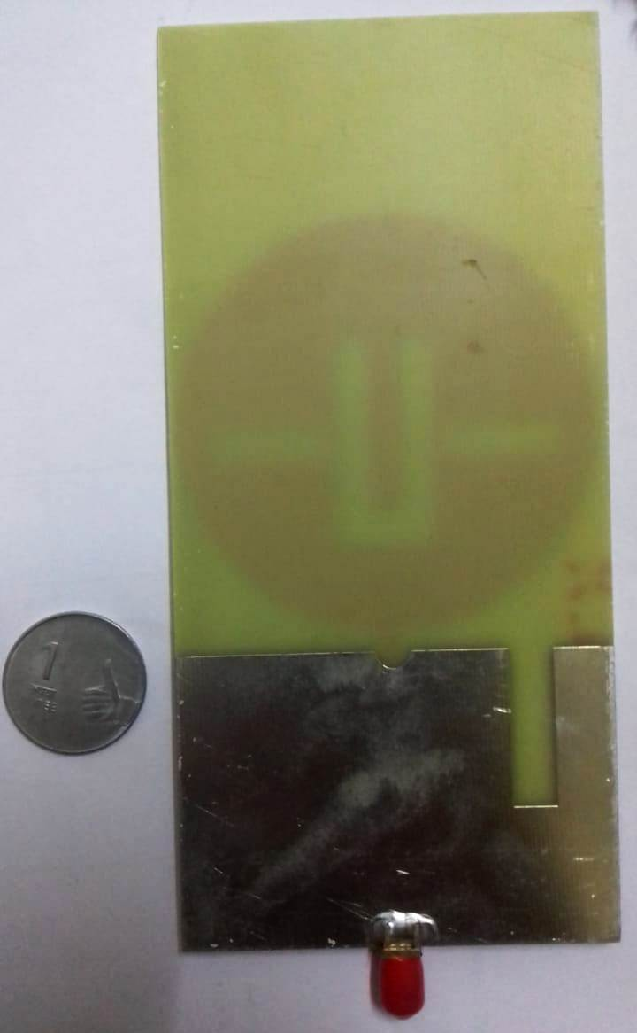
(a) (b)
Fig. 6. Top side view (a) and bottom side view (b) of fabricated slotted monopole antenna

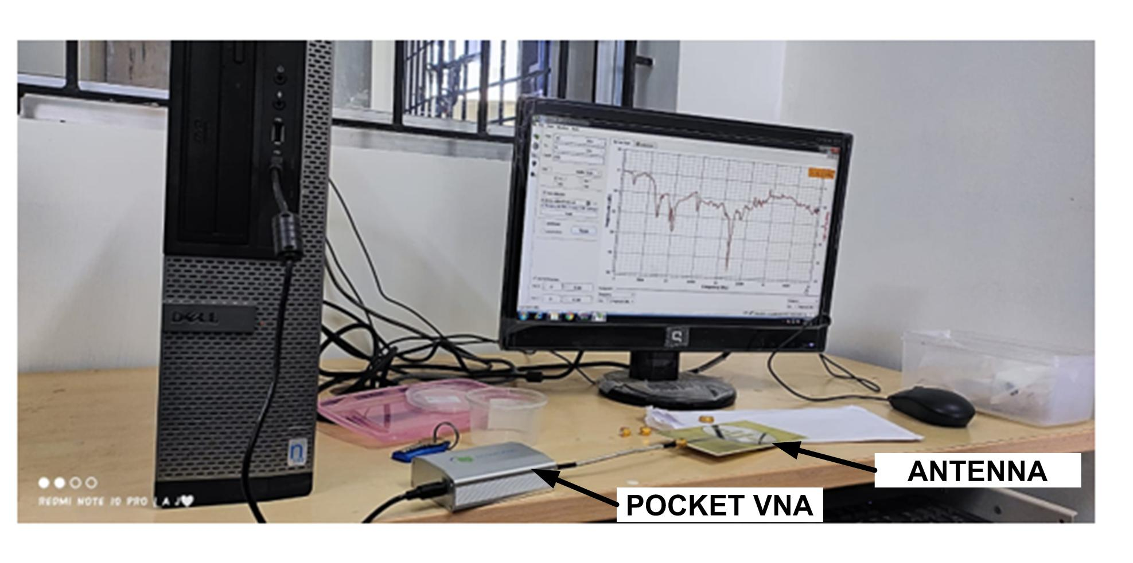
Fig. 7. Experimental set for the measurement of S₁₁ parameter of the fabricated antenna using pocket VNA.

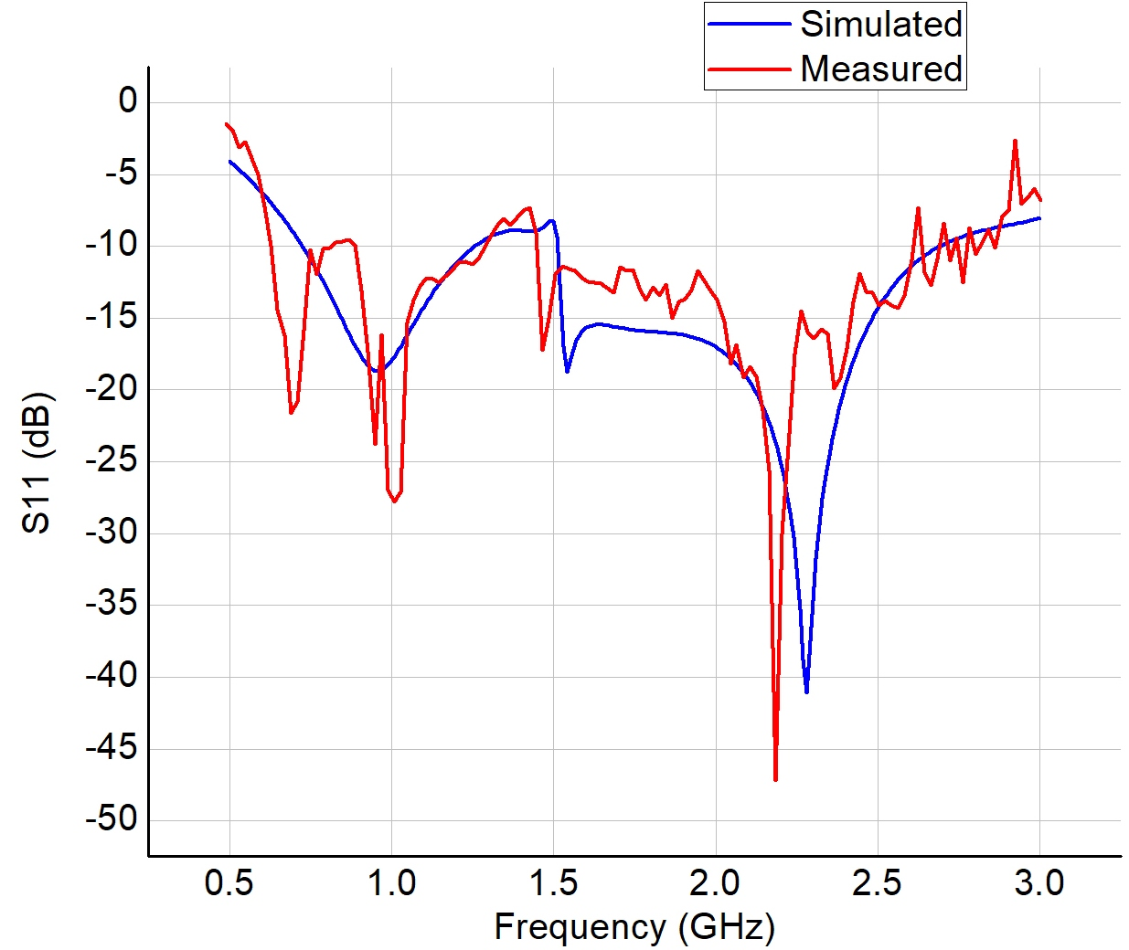

Fig. 8. Measured and simulated S11 parameter for the proposed slotted monopole antenna

IV. Conclusion
A simple circular monopole antenna provides high bandwidth. The lower cutoff frequency of the monopole antenna can be lowered by cutting lots in the radiating patch and/or ground plane, however doing such also introduces some band of frequencies where the S₁₁ parameter deteriorates. The proposed antenna finds application in wireless standards like Wifi, WiMAX, Bluetooth, RFID, GPS etc. and also finds application in energy harvesting.

V. ACKNOWLEDGEMENT
The authors are profoundly thankful to the management of Saveetha Engineering College department of Electronics and Communication Engineering for providing the necessary lab facilities and full support for carrying out this work

REFRENCES
[1] John D Kraus, Ronald J Marhefka and Ahmad S Khan, “Antennas and Wave Propagation”, Fifth Edition, McGraw Hill Education Pvt. Ltd., 2018.
[2] C. A. Balanis, “Antenna Theory Analysis and Design”, pp.728-730, John Wiley & Sons, 2nd Edition.
[3] Girish Kumar and K P Ray,” Broadband Microstrip Antennas”, Artech House Boston • London, pp. 361.
[4] S.De, S.Sarkar, S.Biswas, D.Sarkar and P.P.Sarkar “Investigation on broadband microstrip two element monopole antenna with high gain” IETE Journal of Research, Vol.59, Issue.4, Pp.400-403,2013.
[5] S. De and P.P. Sarkar “A High Gain Ultra-wideband Monopole Antenna” International Journal of Electronics and Communications (AEÜ). Vol.69, Pp.1113-1117, 2015.
[6] S.De, S.Sarkar, S.Biswas, D.Sarkar and P.P.Sarkar “Investigation on broadband microstrip two element monopole antenna with high gain” IETE Journal of Research, Vol.59, Issue.4, Pp.400-403,2013.
[7] S. De and P.P. Sarkar “A High Gain Ultra-wideband Monopole Antenna” International Journal of Electronics and Communications (AEÜ). Vol.69, Pp.1113-1117, 2015.
[8] K. Mandal, A. K. Saw, M. K. Das and PP Sarkar, “Bandwidth enhancement for microstrip patch antenna using symmetric inverted U slot,” International Journal of Electronics and Communication Technology, vol. 3, pp. 64-66, 2012.
[9] Pratyaksh, B. Ananda Venkatesan, K. Kalimuthu, RanvijayTanwar and Harjot Kaur. “Design of Ultrawide Band Planar Monopole Antenna for MIMO Applications.” (2019).
[10] Ming-An Chung and Chih-Wei Yang, “A Miniaturized Planar Monopole Antenna Based on a Coupling Structure for Compact Mobile Internet of Things (IoT) and Electric Vehicles (EVs) Device Applications in 5G, LTE, WLAN, WiMAX, Sirius/XM Radio, V2X, and DSRC Wireless Systems,” International Journal of Antennas and Propagation, vol. 2021, pp. 1-12, 2021
[11] K. Mandal and P.P. Sarkar, “High gain wide-band U-shaped patch antennas with modified ground planes,” IEEE Trans. Antennas Propagation, vol. 61, pp. 2279-2282, April-2013.
[12] A R Rajini , Ebenezer Abishek, S Ramesh, and V Rajendran, “Compact Printed Planar Eye Shaped Dipole Antenna for Ultra-Wibeband Wireless Applications.” Journal of Applied Science and Engineering (Taiwan), vol. 25, issue 5, pp. 761-766, 2021.
[13] Isaac B. T. da Silva, Humberto D. de Andrade, José L. da Silva, Humberto C. C. Fernandes and T. Wakabayashi, “Influence of Complementary Split Ring Resonator Dimensions in Ultra Wideband Microstrip Patch Antenna,” 9th European Conference on Antennas and Propagation (EuCAP), 2015.
[14] Saranya N, Kesavamurthy T. “Design and performance analysis of broadband rectenna for an efficient RF energy harvesting application”. Int J RF Microw Comput Aided Eng. 2019.

